Lab Manual#12`

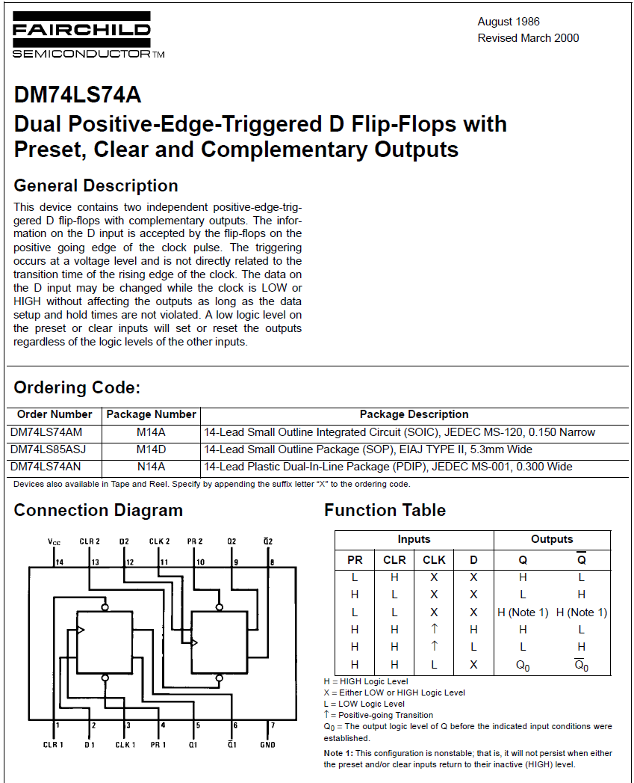

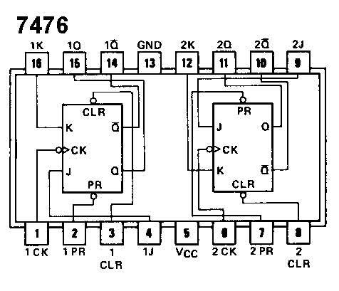
Figure 1: D FF IC

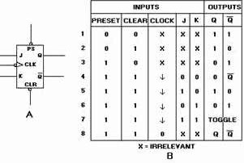

Figure 2: JK FF IC

LLAB Task 1: Design and implement a master slave flip flop. Use D flip flop as master and SR
as a slave in LogicWorks. Make it operate as:
- Negative Edge Triggered
- Positive Edge Triggered
Compare and explain the timing diagram of both

LLAB Task 2: Design and Implement a SR Master Slave Flip Flop using SR flip flops on
LogicWorks with
- Negative Edge Triggered
- Positive Edge Triggered

